**Part One: Analysing and Visualizing Data**

**Data Analysis of Total Sales Revenue by Salesperson for the month of December 2021.**

As seen in the graph below, the best salesperson for the month of December, 2021 is **Nancy Freehafer** who closed a total sales revenue of **$17,137.58.**

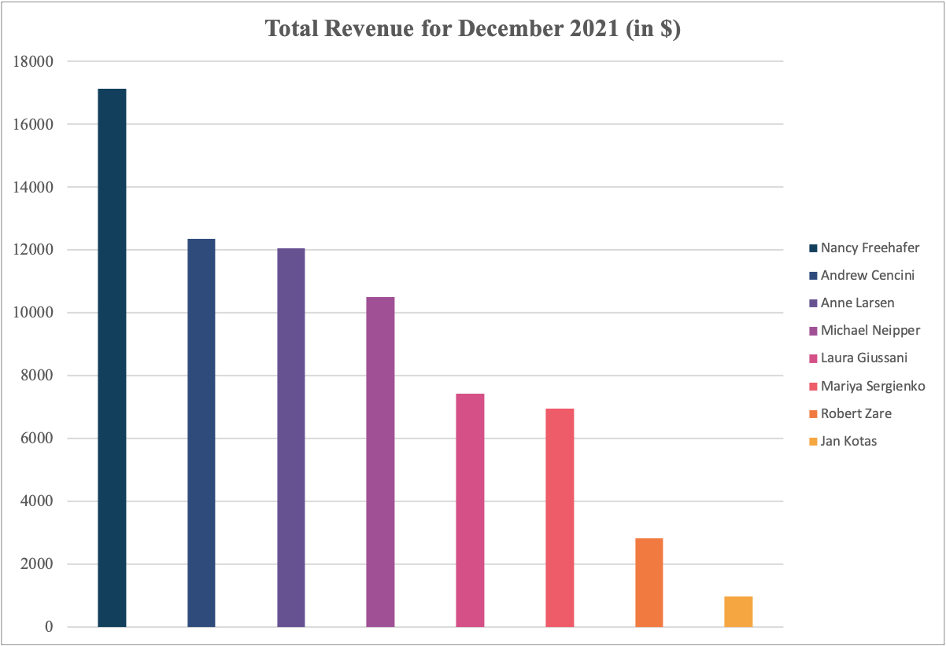

**Data Analysis of Total Sales Revenue by Product Type for the month of December 2021.**

**Coffee** was the most sold product with a total sales revenue of **$12,190** (which contributed to **17%** of the total sales) and **Long Grain Rice** was the least sold product with a total sales revenue of **$196** (which contributed to **less than 1%** of the total sales) in the month of December 2021.

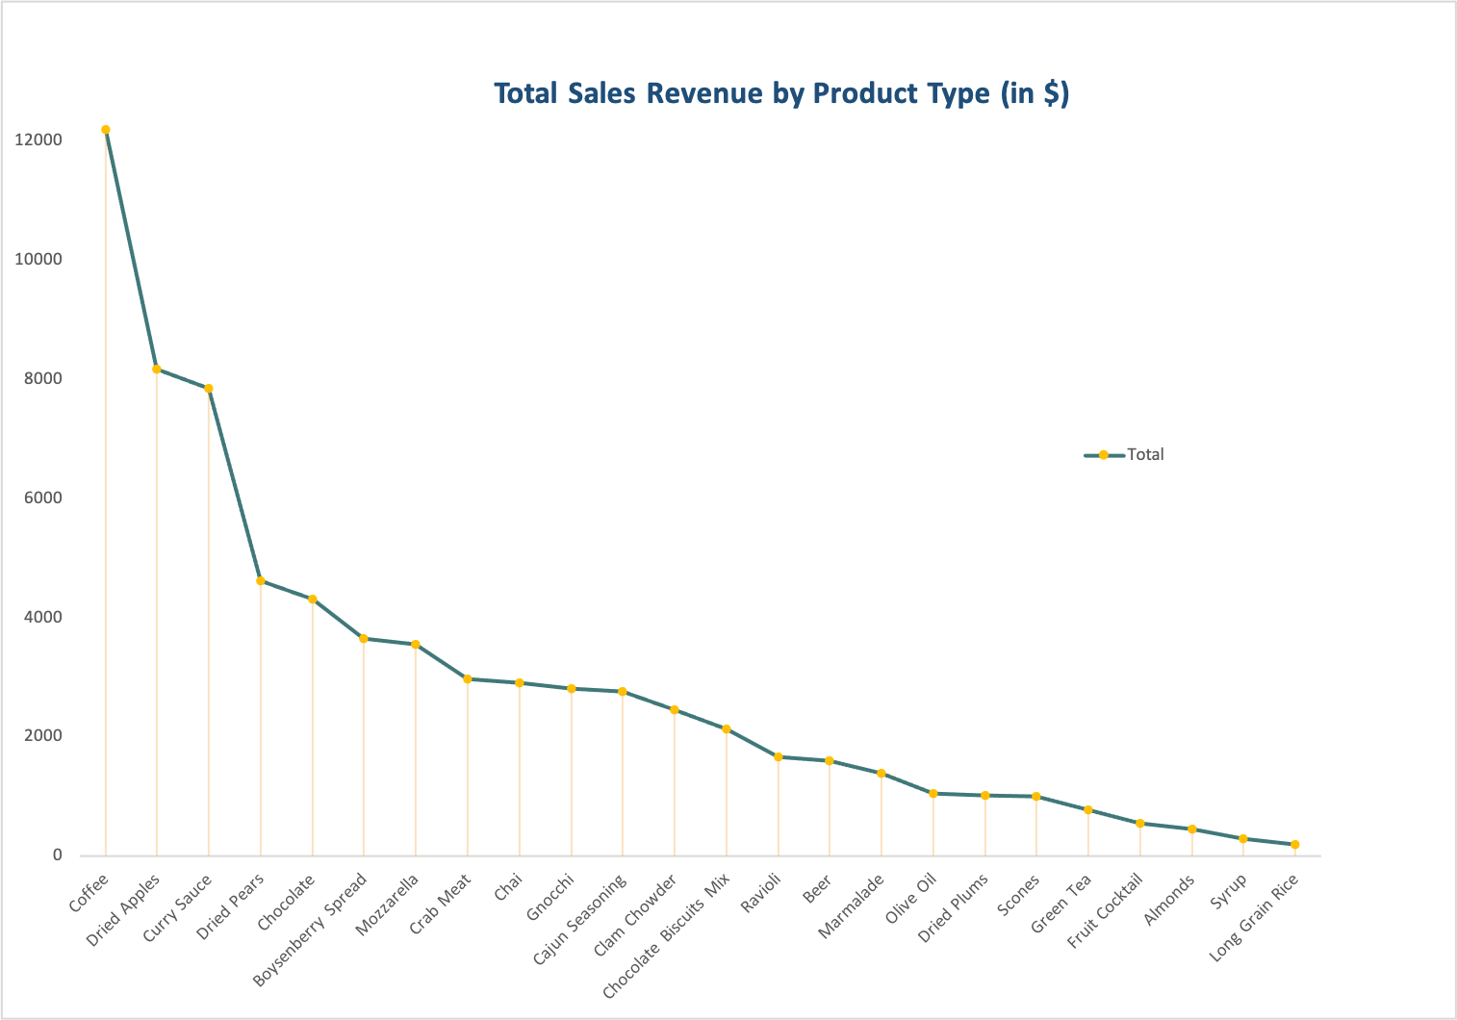

**Data Analysis of Total Sales Revenue by Shipped City for the month of December 2021.**

**New York** had the highest number of sales shipped in December, 2021 worth **$12,368.9** while **Denver** had the least number of sales shipped worth **$979.25**.

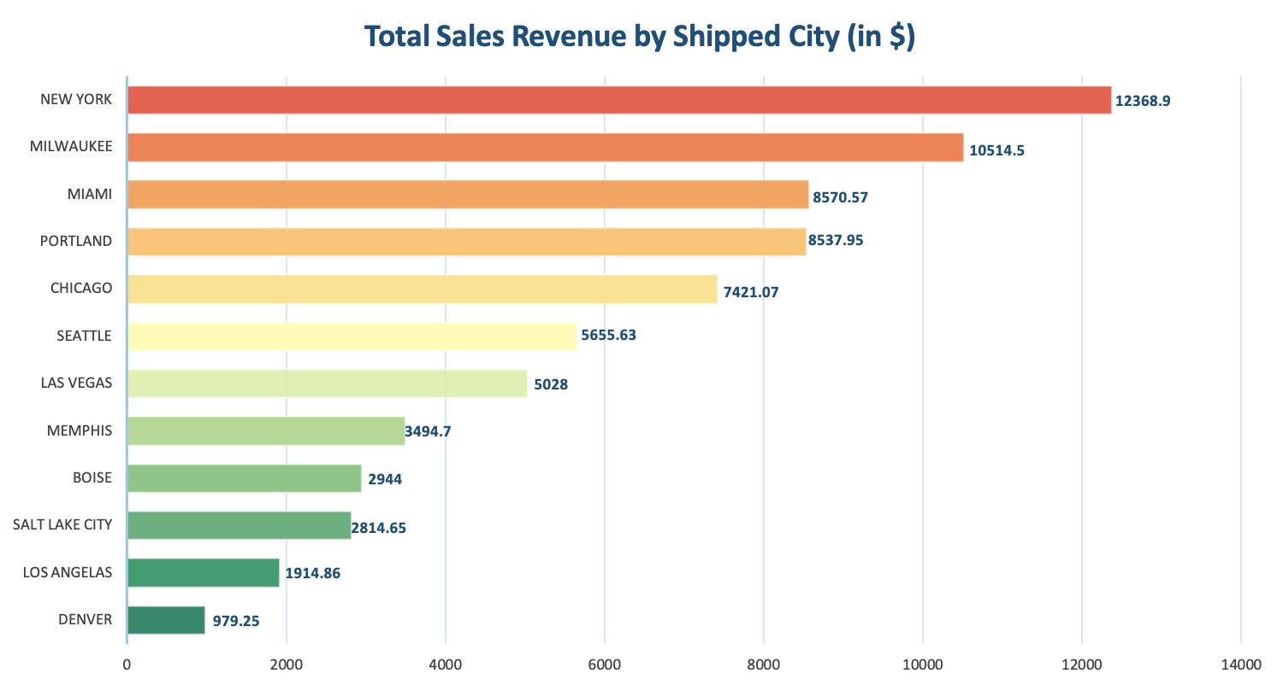

**Part Two: What should the Committee do?**

Analyzing Objective Data to Design & Implement Data and Decisions Course

**Objective**

The objective of this paper is to influence the decision of the Assessment Committee to choose either of the decided two approaches for the Data & Decisions Course through data-based insights and recommendations.

**Background**

There is a disagreement between members of the Assessment Committee on how the D&D course should be designed and assessed. Their overall objective is to choose an approach which helps graduates develop both understanding and confidence on the topic. However, committee members are split on which of two different approaches to course design should be used. Approach One: Some members believe the course should focus 75% on manipulating data, and only 25% on interpreting data. They believe firmly that an exam is the only way to properly teach a quantitative topic and Approach Two: Some members believe the course should instead focus 25% on manipulating data and 75% on interpreting the data for business purposes. They argue that what matters most in the workplace is the ability to provide intelligence and insights based on data analysis. They also believe that the course should be assessed using several different types of assignment questions, and no exams. The last meeting finished without reaching consensus and the decision is currently at a standstill. I discovered a professor at my school who ran a test case, teaching D&D using Approach Two. The course was run for a cohort of 35 MIB students. He collected pre- and post-course data to measure how a course designed using Approach Two affected students’ self-reported levels of understanding, experience, and anxiety about the topics.

**Methodology**

* A professor from Hult used approach two for D&D course on a cohort on 35 MIB students. A pre-course survey was conducted a week before the course began which consisted of 3 questions on experience, understanding and anxiety.
* All students had to complete a second survey, one day after the course finished which consisted of 5 questions in total on experience, understanding, anxiety, difference and improved. Few of the original questions were repeated in order to provide a pre and post intervention measurement. Most of the variables were measured using the 7-point Likert response scale but anxiety was measured using a sliding scale ranging from 0 to 100.

**Findings**

* There was a significant increase in understanding post-course when compared to pre-course results. (p=0 < 0.05)
* There was a significant increase in level of experience rating post-course when compared to pre-course results. (p=0 < 0.05)
* There was a significant decrease in anxiety post-course when compared to pre-course results. (p=0 < 0.05)
* On average most students improved on how to use data to drive their decisions. (Mode =6, SD= 0.65, p=0.02 < 0.05)
* More than 70% of the students had significant increase in understanding the difference between qualitative and quantitative research data. (Mode =6, SD= 0.45, p=0.02 < 0.05)

**Recommendations**

* The committee should implement approach two for data and decisions course as it effectively developed both knowledge and confidence in students.
* While implementing, the course must focus less on manipulating data and more on interpreting the data as it helped students deliver more data- driven decisions
* The committee should not use exams as assessment, rather use different types of assignment questions as it decreases anxiety, increases understanding and level of experience.

**Thejaswini Paripally**

**Assessment Committee Representative**

**February, 2022**

**Part Three: Data Analysis in Business and Society**

**Most of our decisions are biased, even when we think we are being objective**

All of us humans are majorly influenced by either internal biases (such as gender, culture or ageism) or external biases (such as environmental or social influences) while perceiving and understanding things which affect our decision-making process. Most of this information we receive is unconsciously processed quickly by our default system in our brain without our knowledge whereas we consciously only process few bits of data we receive every day. With these biases, our mind automatically responds by making decisions and judgements based on intuition or outcomes that either actually occurred in the past or possible future outcomes or based on previously held beliefs which leads to irrational errors and choices which affect various behaviours such as judgement, social interactions and decision making.

Data has always been a part of our life, but most of the companies till date use their past experiences or blindly just believe what they see or hear on media, or try to come up with ideas or solutions or top of their mind responses to make business decisions convincing themselves that they are being objective rather than analysing reliable data at hand to reach conclusions and make data- based decisions. With the recent trend, hype and the rising demand of big data and artificial intelligence everywhere, data analytics is being adapted rapidly by small and big organizations to gain data-based insights to make informed decisions, venture into new markets, run their company effectively, convert the meaningful data into new opportunities and to make smarter business choices.

Since the data can be molded and shaped in any way you want, it can be interpreted in several ways therefore it’s important to be mindful while looking for the right findings. Also, the recommendations the company decides should be based on the data itself and not on biases or any top-of-mind approach.

**REFERENCES:**

Oreskes, N. (2020, June 1). Small numbers can have huge impacts on climate and health. Scientific American. Retrieved from https://www.scientificamerican.com/article/small-numbers-can-have-huge-impacts-on-climate-and-health/.

Lopez Yse, D. (19 September 2020). The secret weapons of fake news. Retrieved from https://www.datasciencecentral.com/profiles/blogs/the-secret-weapons-of-fake-news.

**Part Four: Demonstrating Learning**

**Insight 1:**

Having a good reason or a good idea does not make it a data-based reasoning. A data-based approach involves observing, asking the right questions, measuring, predicting and testing instead of guessing or giving top of the mind responses.

**Insight 2:**

Quantitative data gives objective findings as it’s based on numerical data whereas Qualitative data is more subjective and descriptive as it provides deep insights on the qualities and actions that drove the consumers.

**Insight 3:**

Descriptive Statistics helps in simple interpretation of complex data-sets in an understandable and meaningful way. It calculates representative values such as standard deviation, mode, mean and median for the given data-set which helps in reaching conclusions in order to make rational data-based decisions.

**Insight 4:**

Inferential Statistics helps in finding patterns about the larger data set by studying subsets and expecting the outcomes will infer to the whole group. It provides explanation for a phenomenon and helps in drawing conclusions based on predictions and estimation.

**Insight 5:**

Attribution theory explains how we tend to reason our actions and behavior as explanation for various situations. It shows how we hold various unconscious and implicit biases either influenced by internal or external factors which affect our decision making, this causes us to trust our past experiences more than reliable data.

**Insight 6:**

Effective advertising should use creativity to bring attention to the brand, have an emotional impact on the customers, build a strong connection and bond, increase credibility and influence people to take an action.